|  |  |
| --- | --- |
| **Auteur(s):** |  |
| Naam 1  Naam 2 |  |

|  |
| --- |
|  |
|  |
| *Ondertitel* |

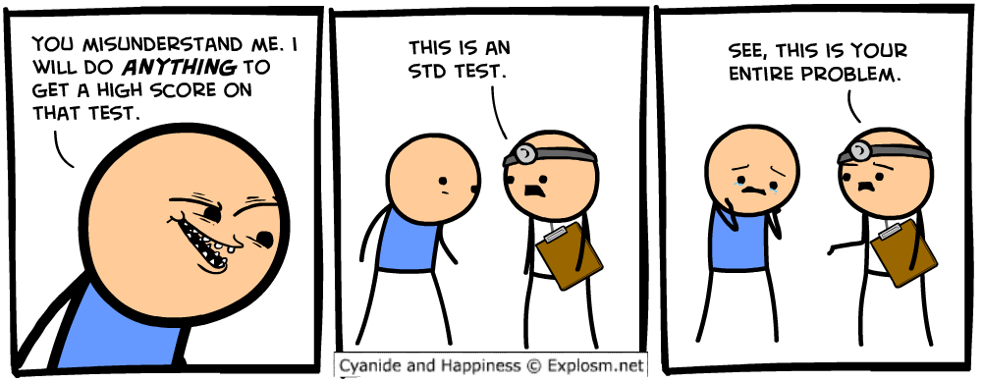

Acceptatietest

|  |  |
| --- | --- |
| **Functionaliteit** |  |

|  |  |  |  |  |  |  |
| --- | --- | --- | --- | --- | --- | --- |
| **Actie** |  | | | | | |
| **Scenario** |  | | | | | |
| **Verwacht resultaat** |  | | | | | |
| **Werkelijk** **resultaat** |  | | | | | |
| **Aanpassingen** |  | | | | | |
| **Uitvoering** | **Uren** |  | **Prioriteit[1]** |  | **Door** |  |

|  |  |  |  |  |  |  |
| --- | --- | --- | --- | --- | --- | --- |
| **Actie** |  | | | | | |
| **Scenario** |  | | | | | |
| **Verwacht resultaat** |  | | | | | |
| **Werkelijk** **resultaat** |  | | | | | |
| **Aanpassingen** |  | | | | | |
| **Uitvoering** | **Uren** |  | **Prioriteit\*** |  | **Door** |  |

|  |  |  |  |  |  |  |
| --- | --- | --- | --- | --- | --- | --- |
| **Actie** |  | | | | | |
| **Scenario** |  | | | | | |
| **Verwacht resultaat** |  | | | | | |
| **Werkelijk** **resultaat** |  | | | | | |
| **Aanpassingen** |  | | | | | |
| **Uitvoering** | **Uren** |  | **Prioriteit\*** |  | **Door** |  |

1. Gebruik voor de prioriteit de volgende codering:  
   1 = Laag  
   2 = Middel  
   3 = Hoog